A PROJECT REPORT ON

DOOR SENSOR ALARM SYSTEM

SUBMITTED BY- TABASSUM

ABSTRACT

The need for door sensor system is a serious demand. As the numbers of crimes are increasing every day, there has to be something that will keep us safe. We are all aware of the high end door sensor present in the market. But they are not easily available to everyone. We therefore intend to provide a solution by constructing a cost efficient electronic system that has the capability of sensing of door is open or closed and turn on the LED. The basic idea behind this project is that when door is open then LED will glow.

The project involves the use of atmega328p microcontroller, LED, resistor and a simple program.

TABLE OF CONTENTS

1. Introduction

2. Requirements

3. Design

4. Simulation

5. Output

INTRODUCTION

Door Sensor System is a project that enables to sense the Door is open or closed. This project can be use in home, organization, and many other places. This is implemented in C. C is a platform independent language. Its created project can be used on a standalone machine. The objective is to construction an electronic circuit that acts as a watch dog. It is used to protect a door when it is ON. It turn on LED when the door is open. Alerting you if someone opens, or tries to open , the doors in your home. Anyone can use Door Security System in home, in hospital, in any organization. Door Security System can be very effective home security device. This project uses simple functions. It is very easy to work. By using atmega328P microcontroller it can be achieved. This Project requires a lost cost of development. The project involves the use of atmega328p microcontroller, LED, resistor and a simple program

REQUIREMENTS

HIGH LEVEL REQUIREMENTS:

In this Project we use a atmega328P microcontroller, a LED, an audio out device and a resistor.

1. This can be use in door of a car. If door of a car is open then this buzzer will produce sound and LED will glow.

2. This can be use in a home for security purpose. Alerting you if someone tries to open the door.

LOW LEVEL REQUIREMENTS:

This project is implemented by using c language in both windows and Linux OS.

DESIGN

The flow chart of Door Sensor .

LED WILL NOT GLOW

LED WILL GLOW

DOOR OPEN??

START

FIG-1

STRUCTURAL DIAGRAM OF DOOR SENSOR SECURITY SYSTEM

FIG-2

LED

SWITCH AS A DOOR

ATMEGA 328 MICROCONTROLLER

HOW TO USE THIS PROJECT....?

1. Press the Switch button.

2. Open the switch.

3. LED will glow.

4. Buzzer will produce sound.

5. Close the switch.

6. LED will off.

7. Buzzer will not produce sound.

OUTPUT

1.WHEN DOOR IS OPEN .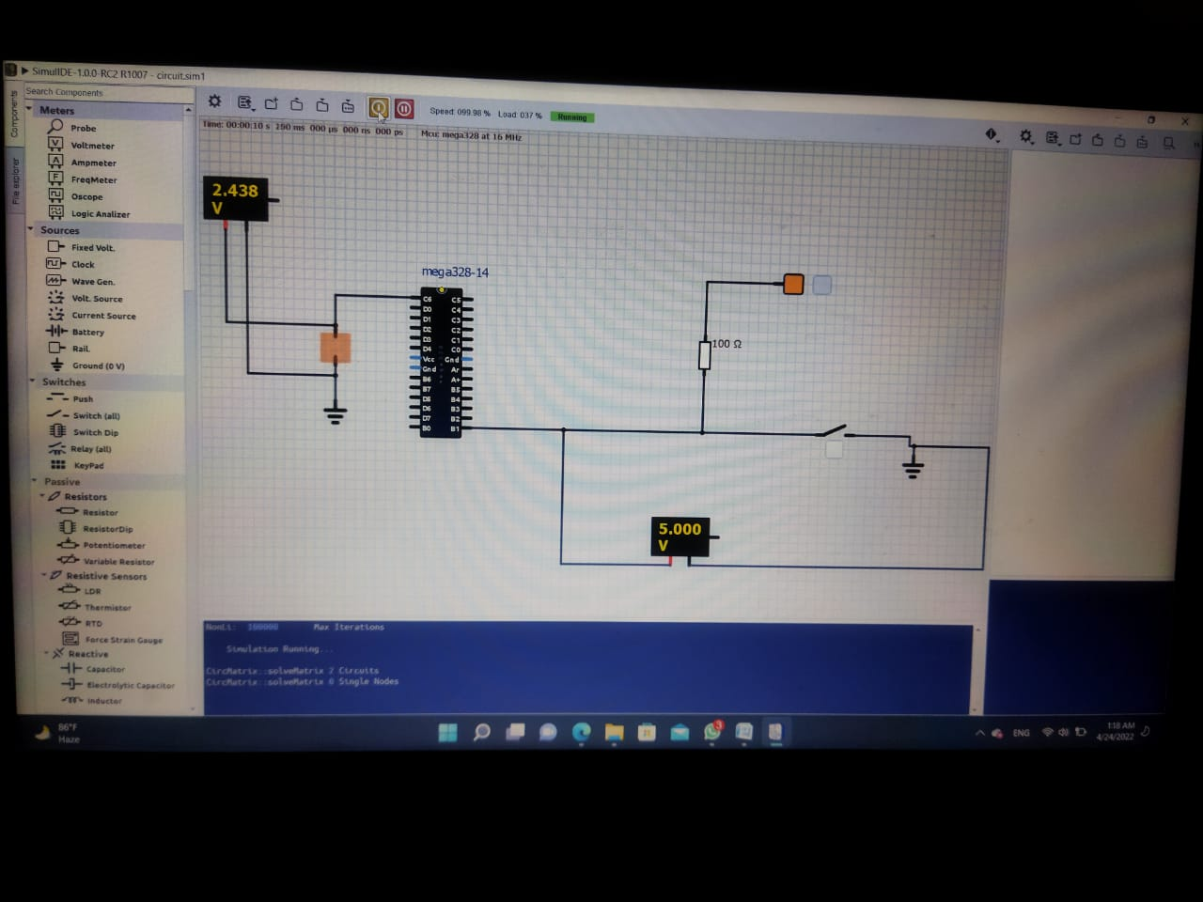

2. WHEN DOOR IS CLOSED. 